1. Run an instance of nginx:alpine with a name nginx and map port8080 on the container to 38282 on the host.

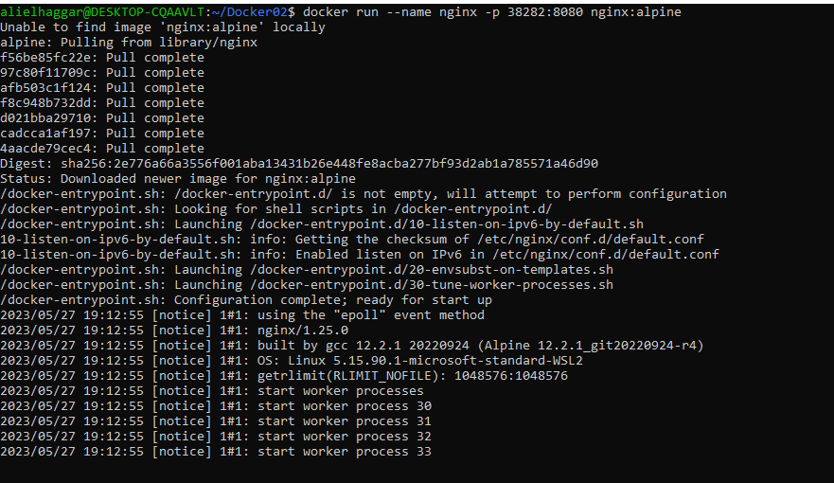

1. create ubuntu image and check the size of it

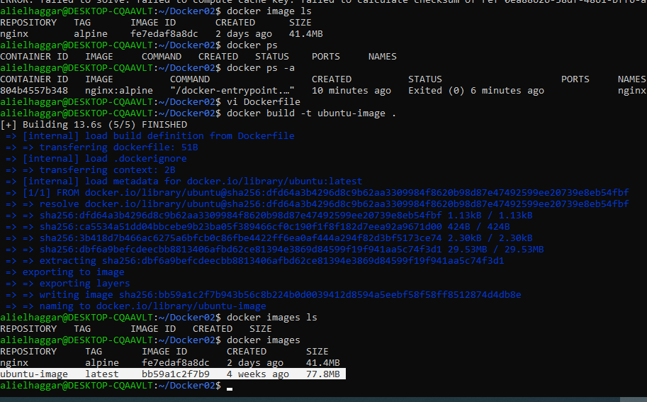

1. Run a container named blue-app using image kodekloud/simplewebapp and set the environment variable APP_COLOR to blue. Make the application available on port 38282 on the host. The application listens on port 8080.

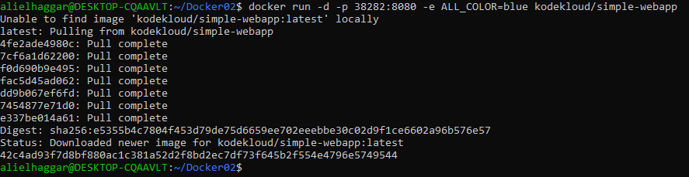

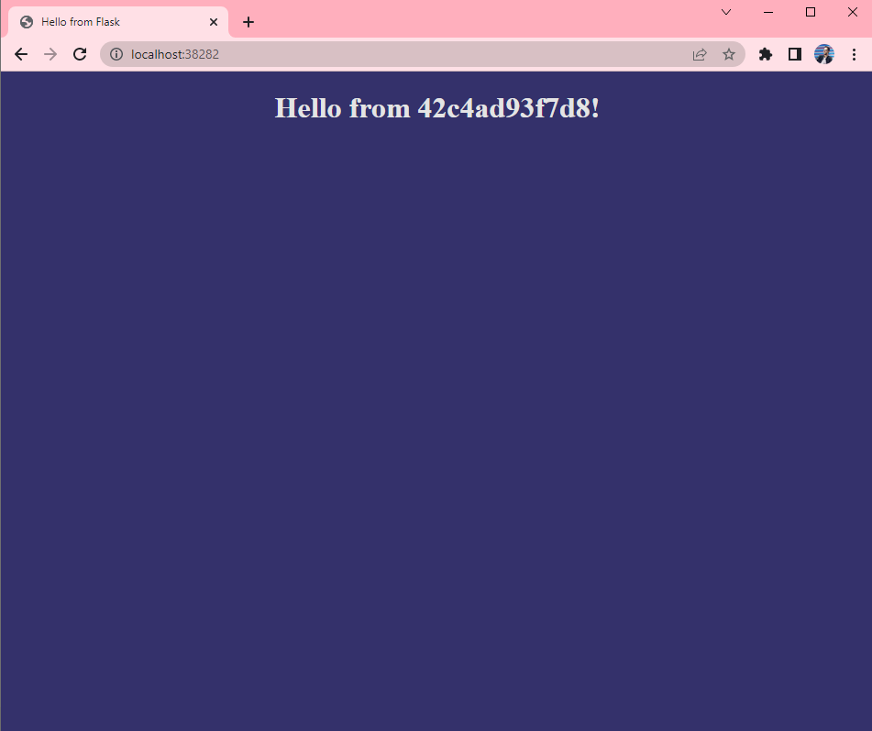

1. Deploy a mysql database using the mysql image and name it mysqldb Set the database password to use db_pass123 then inspect it to

check the value

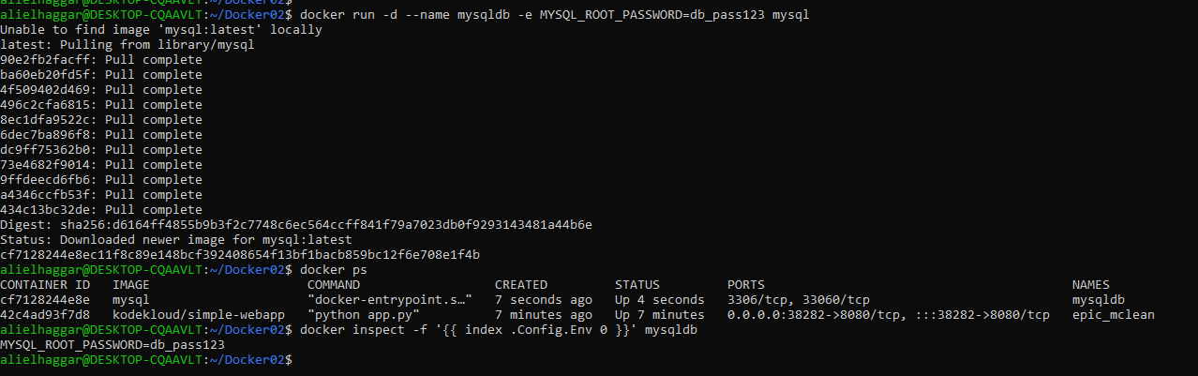

1. pull the code from https://github.com/sabreensalama/dockerizenode-app-task and create a docker file for this flask app

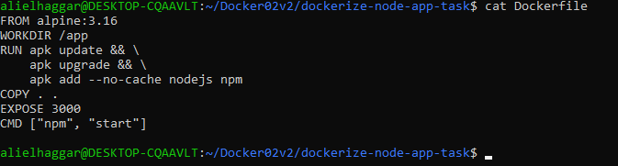

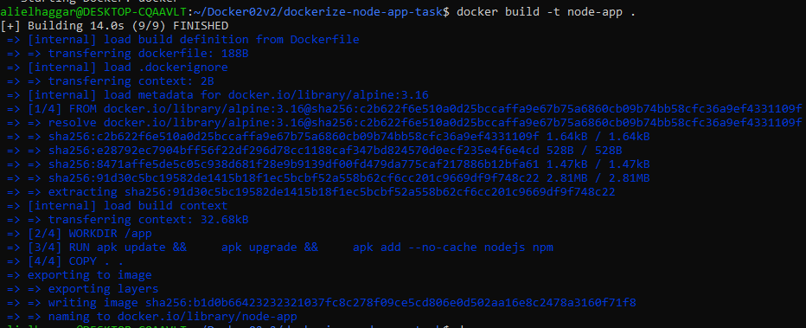

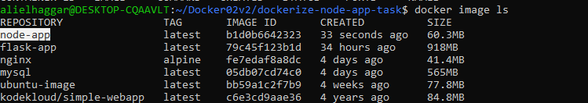

1. Create a volume called mysql_data, Run a mysql container again,but this time map a volume to the container so that the data stored by the container is stored at /opt/data on the host. Use the same name : mysql-db and same password: db_pass123 as before. Mysql stores data at /var/lib/mysql inside the container.

